Environmental Factors:
Solar energy vastly affects the economy of the country. The total system takes into consideration long term average environmental conditions, loads, fuel costs, and other economic factors. The system affecting, indirectly, the industry of fuel and provide the electricity from a bigger natural resource, the sun, than provided in the country by the government. In Pakistan, this activity cannot be easily done without the support of government. Billions of rupees invested in creating the electricity from fuel and water but don’t use solar energy to create the electricity by creating an effective plan because of already has bad experience in this sector but government should make some effective plans and strategies to provide the electricity to the people with thirty to thirty five years warranty/guarantee, whereas an UPS only helpful within 2-4years and will only work when it is charged with electricity(no electricity no charging, no charging no electricity). By mitigating the risk of fuel-price volatility and improving grid reliability, solar electricity can guarantee a more stable energy economy.
Technological leadership is necessary for economic competitiveness and to make solar electricity a significant contributor to the nation's economy.
United States: Electricity Net Generation by Source for 2000 (EIA Annual Energy Review (2000))
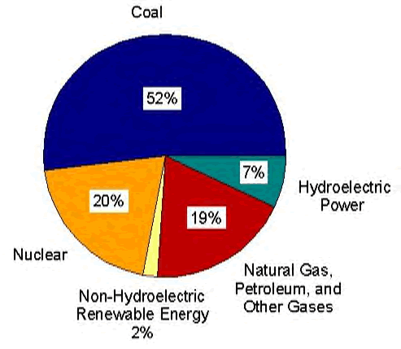

Solar energy harnesses power from the sun, storing it in specially designed battery packs for use.
While the size of the solar system varies depending on the application, most solar systems consist of three major components: the panels, the charge controller and the special solar battery pack.
Here are just some of the key advantages of our solar solutions:

KEEP YOUR MOOLA!
- ✴ No installation costs
- ✴ No wiring costs
- ✴ No electricity bills
- ✴ No maintenance bills
- ✴ No backup systems needed
KEEP IT CLEAN
- ✴ Clean and elegant installations
- ✴ Green energy
- ✴ Zero emissions
- ✴ Totally recyclable
KEEP YOUR SANITY
- ✴ No power outages/breakdowns
- ✴ Minimal maintenance
- ✴ Freedom from noisy generators
- ✴ Works even in cold climates

